Biological Indicator Incubator——B80
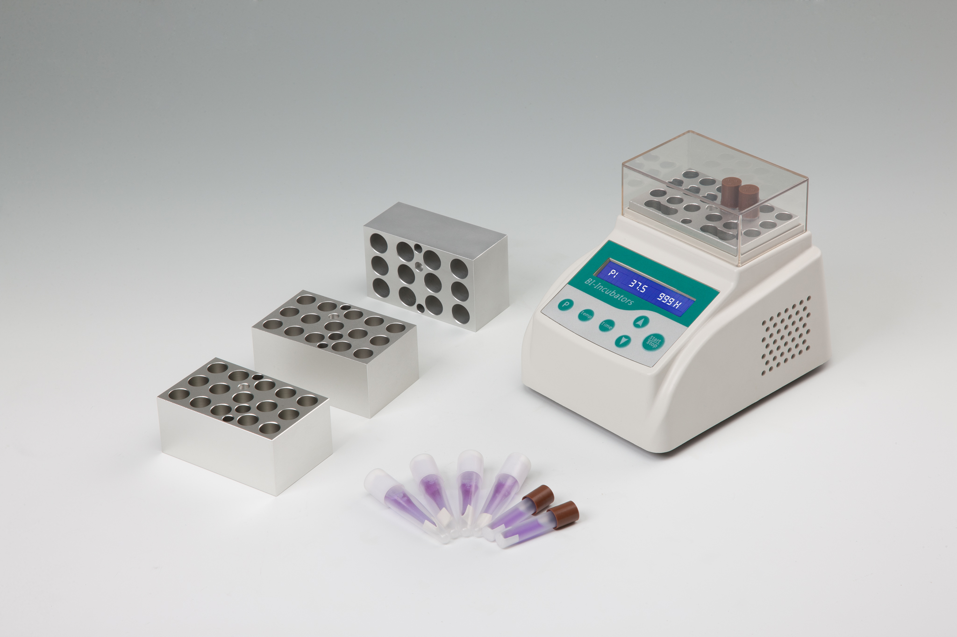
Product Description
The B80 Biological Indicator Incubator is compact, versatile, reliable and easy to use. Designed for single temperature incubation of the EO Biological Indicators. The thermometer is included with the incubator, provides easy verification of incubation temperature.

Features:
- Energy-efficient design.
- Applicable to 24V power adapter.
- Accurate to ± 0.3℃.
- Process of experiment is visible.
- Electronic calibration. User can reset to any local standard.
- Power supply provided is UL, CSA and CE approved.
- Custom blocks made to fit any sample holder.

Parameters:
Type  Parameters | B80
Temp. range | RT+5℃~100℃
Temp. accuracy | ≤±0.3℃
Timing range | 1min~99h
Temp. uniformity | ≤±0.3℃
Display accuracy | 0.1℃
Temp. stability | ±0.3℃
Heating time | ≤6min( 20℃~56℃)
Voltage | DC24V/1.67A
Dimension(mm) | 145×113×110
Weight(kg) | 0.5

Optional Blocks:
Type Tube Diameter Capacity
MD40 Φ10mm 15
MD41 Φ12mm 12
MD42 Φ15mm 8
MD43 Φ16mm 8
MD45 Φ9mm 18

